Clean up all parts.

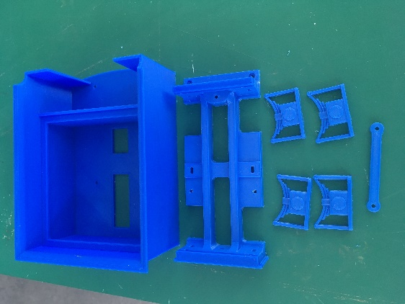

Put 2mm nut in hole for coupling.

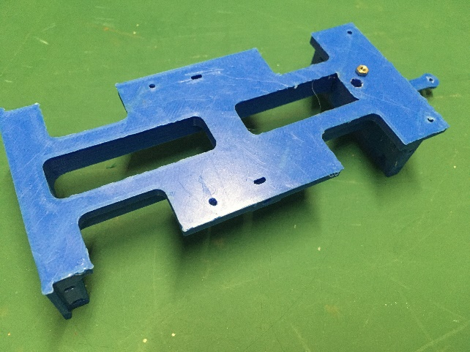

Use 2mm x 10 bolt and screw into nut, make sure it swivels freely then put drop of superglue onto nut and end of bolt.

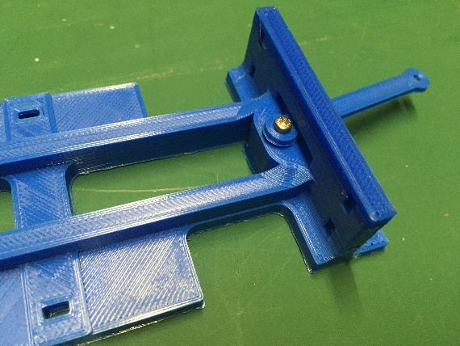

Glue 2 x 2mm nuts into chassis at front of tender.
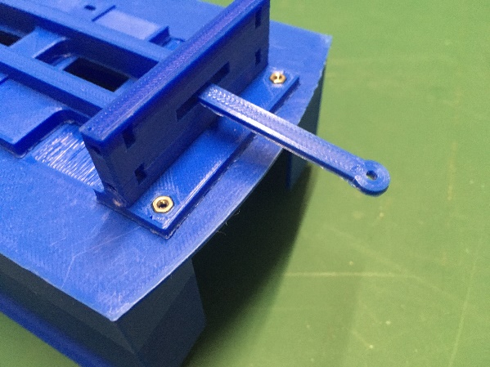

Bolt chassis to tender body with 2 x 2mm x 6mm bolts at front and 2 x 2mm x 8mm bolts at near, with nuts underside.

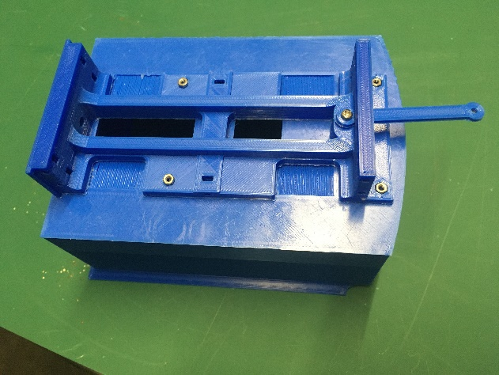

Put 5 x 2mm nuts either side into slots in chassis. Glue 1/8 brass bearings into metal side frames from the inside ( you may have to file the holes out ).
Bolt 1 side frame with 2 x 10mm bolts into captive nuts. Put wheels onto axles ( 28mm inside flange ). Put axles into bearings and bolt the other side frame on.

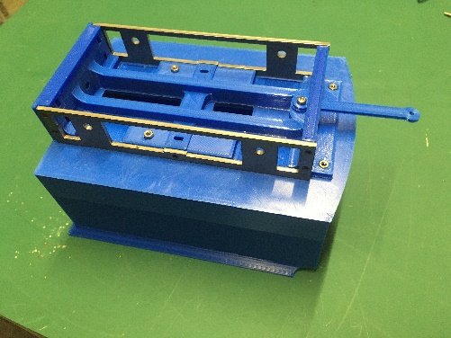

Glue axles boxes to side frames.

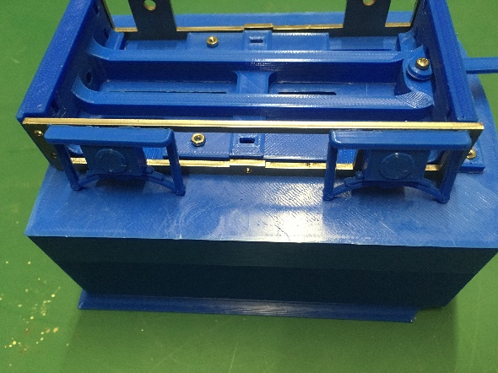

Complete Tender

