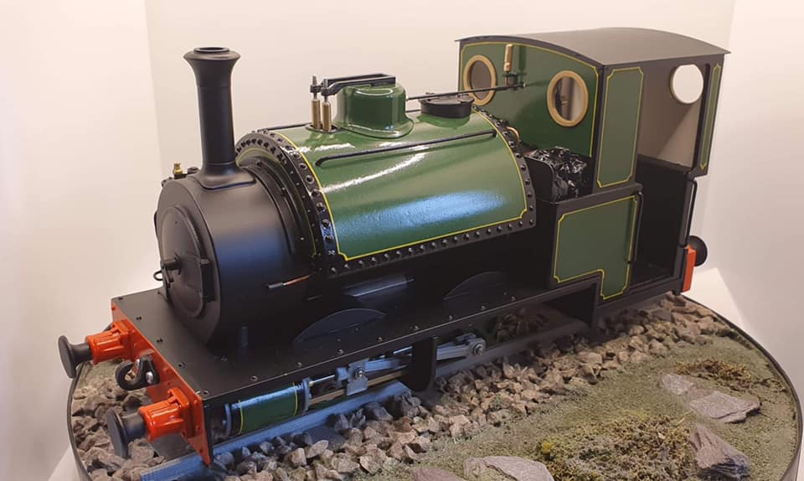
Sir Haydn

By Peter Farley
Please contact
learobinsonpdf@gmail.com
07340542782
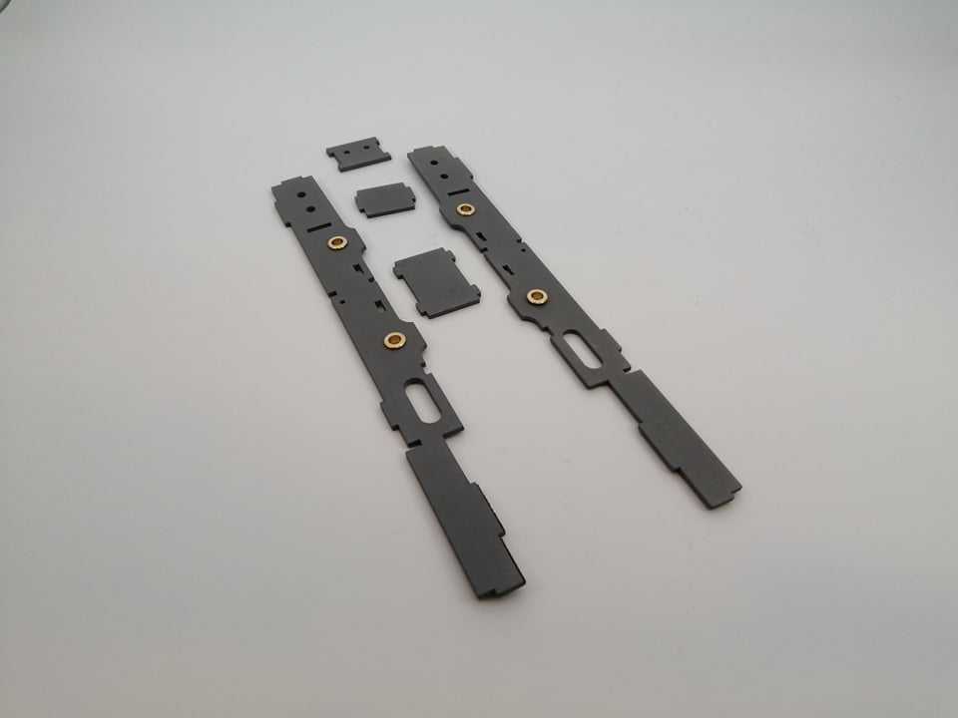
1.
1-10 is making the chassis find these 4 pieces and press in the 3/16 brass bearings on outside of the frame. Glue bearing in with a small amount of superglue. Put the chassis togethers before painting.
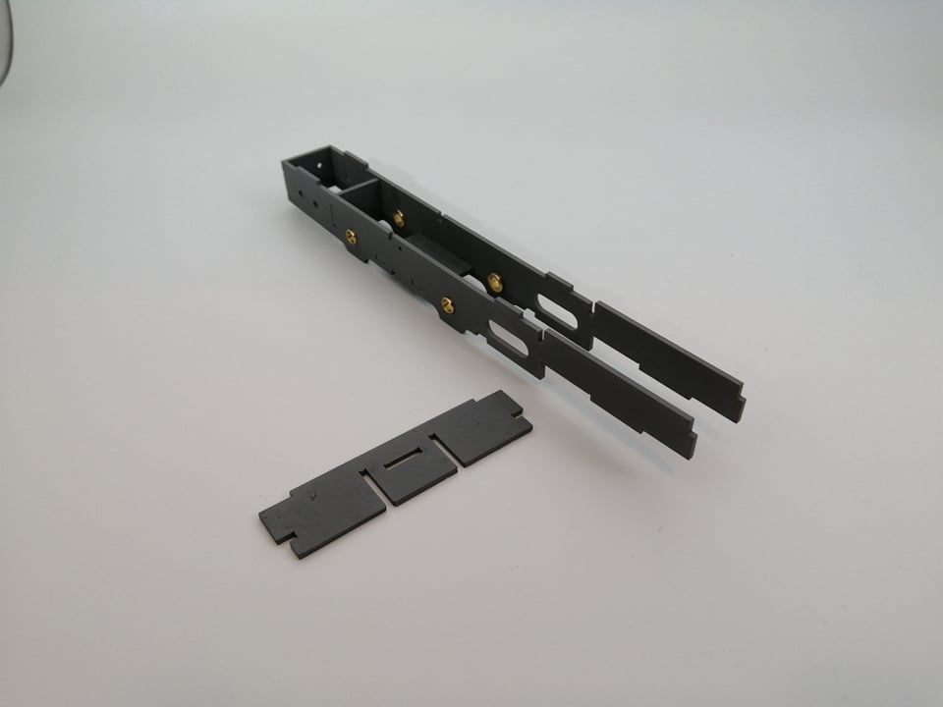
2. Glue with either acrylic cement of super glue

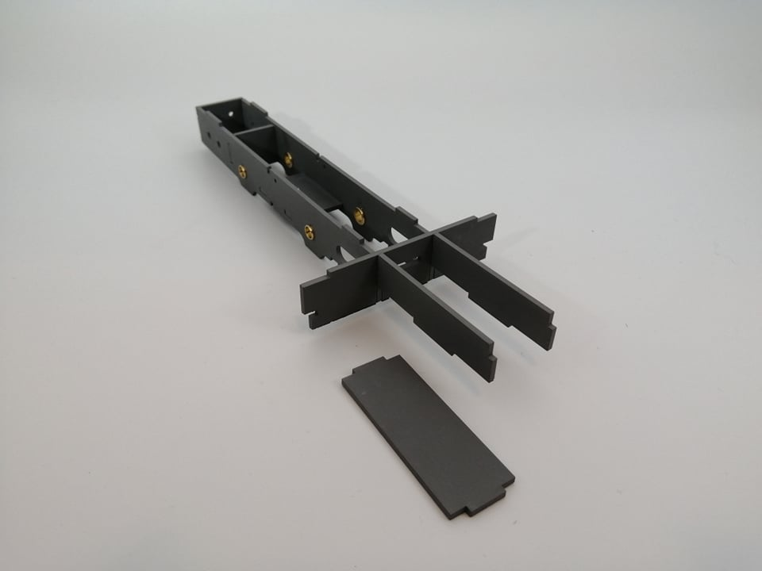
3.

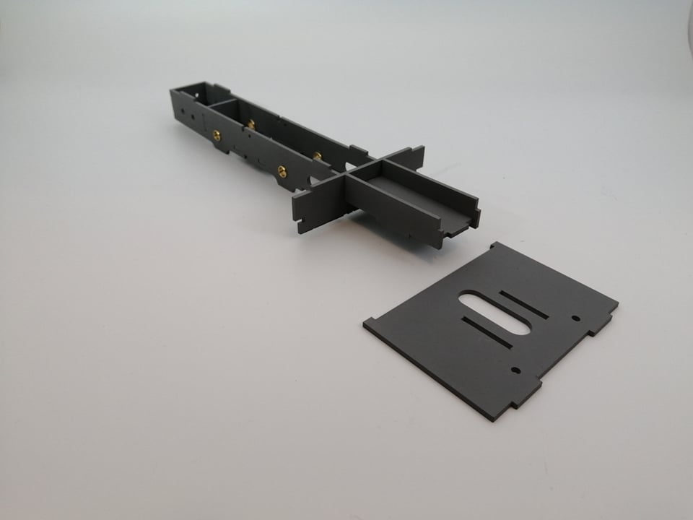
4.

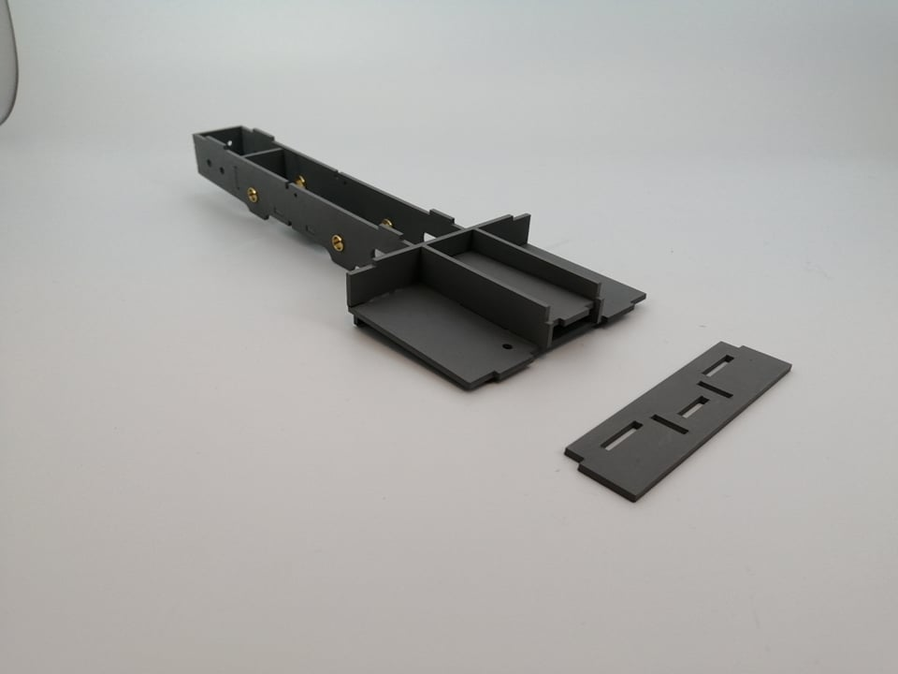
5

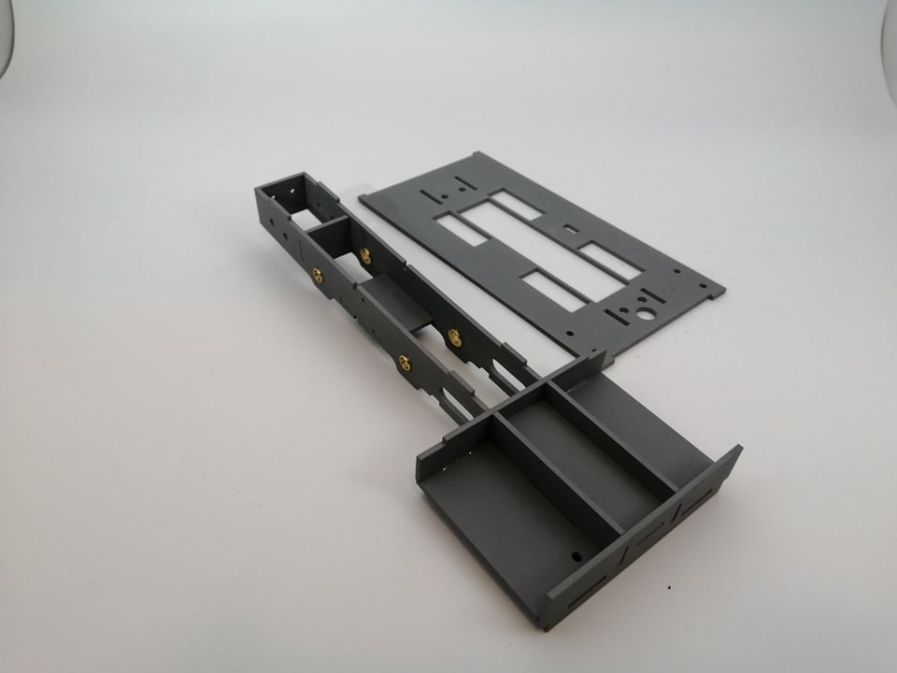
6

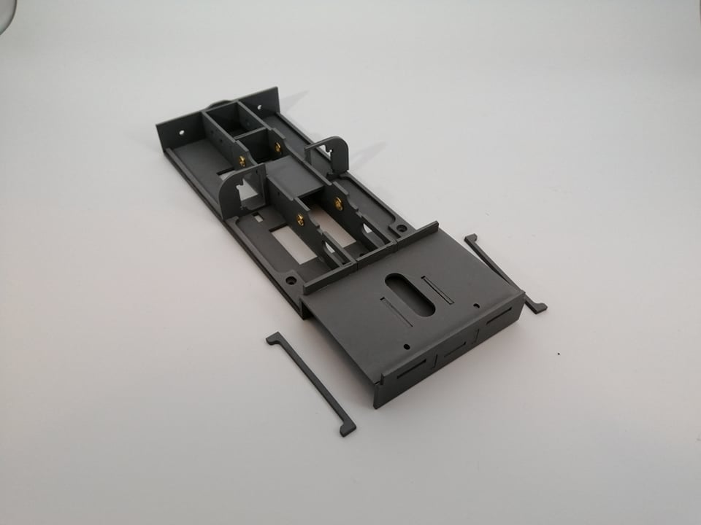
7

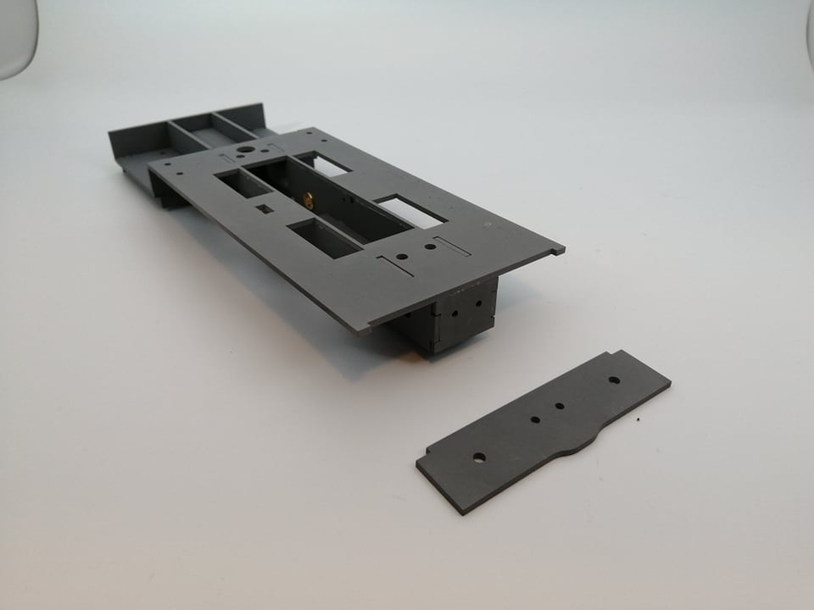
8

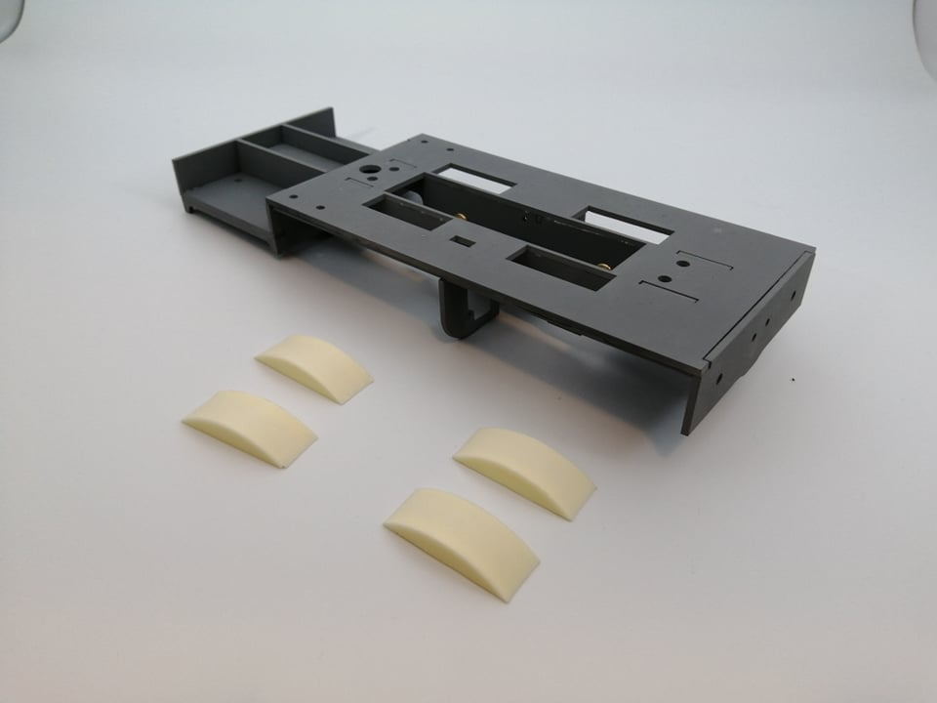
9. Glue resin castings to the acrylic with super glue

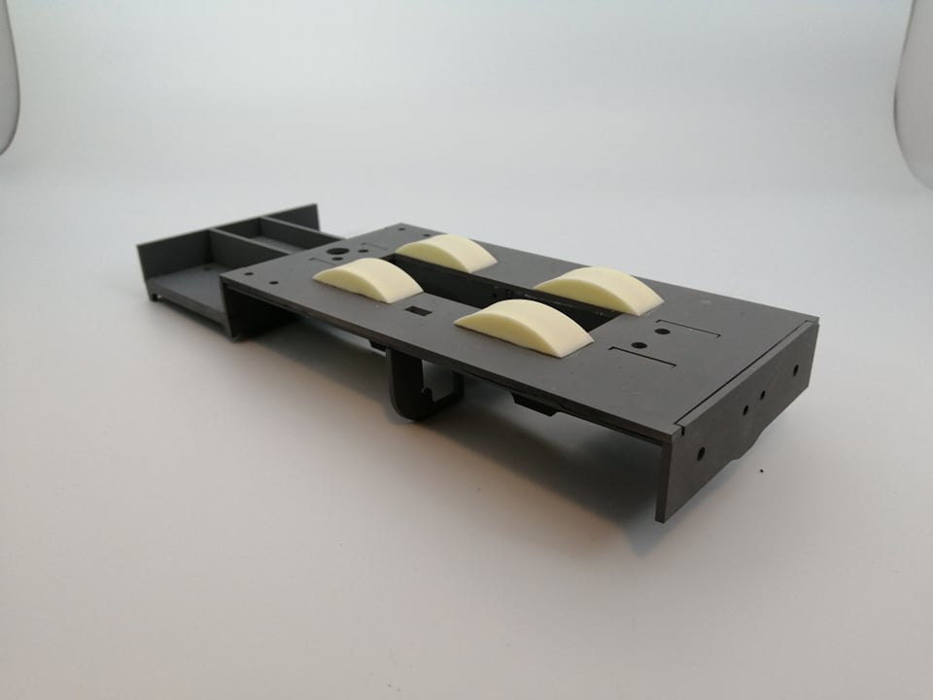
10. Rub down with wet and dry 400 to give a good key. Then spray paint with Halfords grey primer. When dry stick rivets at 5mm intervals with plastic cement. When dry paint primer then paint colour of your choice (Halfords paint)
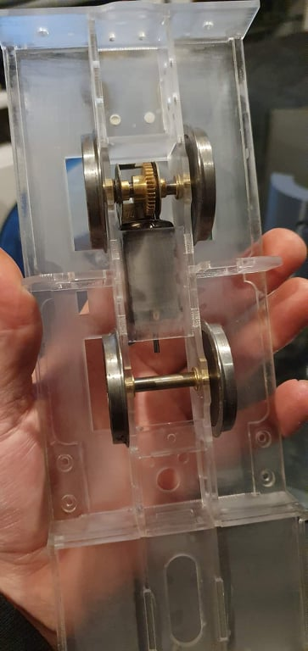
11. Two slater’s wheels ref:16828T and ref:7824.
Fit wheels and gearbox as per instructions. The motor you can just see by the gears.
next take the cylinders push in the 3mm x 20mm brass tube must
have about 7mm sticking out you will see that there 2 sq holes in the rear of the cylinder push in the
2 sq brass rods and the rear cylinder cover
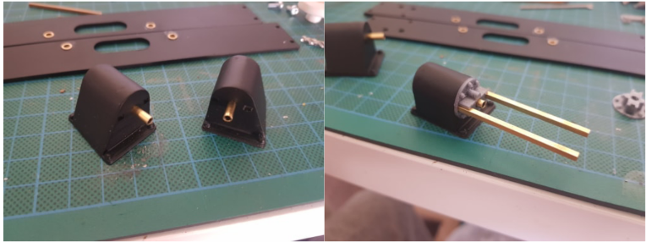

Take the 2 cross-heads and glue in the 2mm steel rod next fit the cylinder to the chassis with 2 3mm
x 8 cab head bolts slide the cross-head in to the tube then fit the slider bar holder test the cross-head
must move freely once happy it moves freely add a dab of glue to the slide bar holder and use super
glue on the rear cylinder cover and slide bars leave to dry.

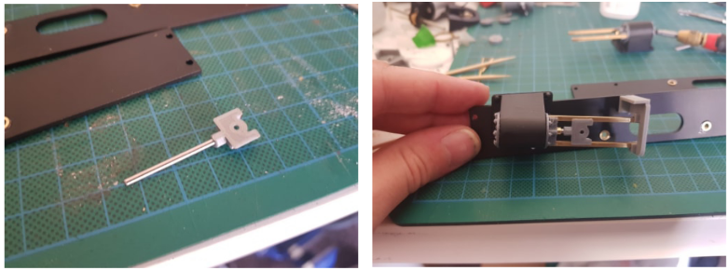
Next remove the cylinder from the frame take the connecting rod and countersunk the small end
then fit to the cross-head with a 2mm x 6mm long bolt and nut do not tighten leave loss to float
about again make sure it moves freely
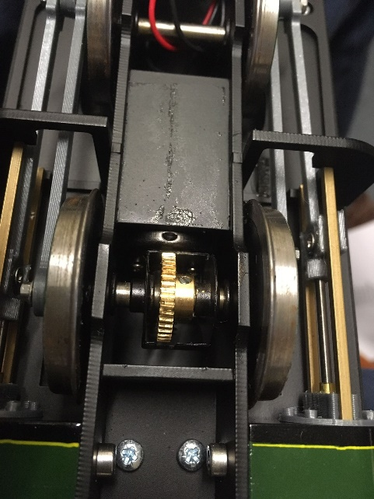
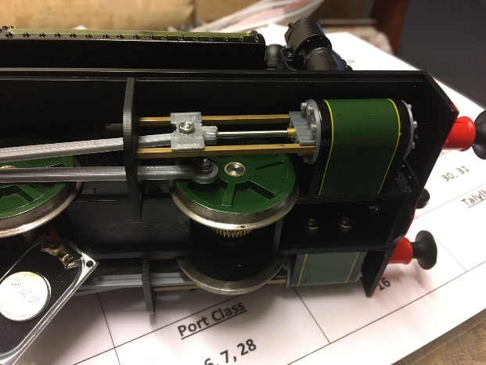
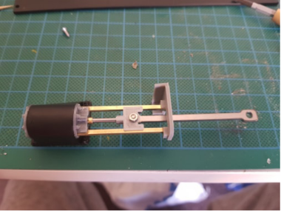

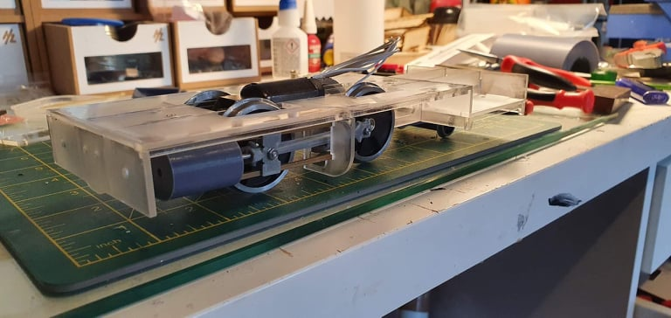

12. The small wheels for the back.

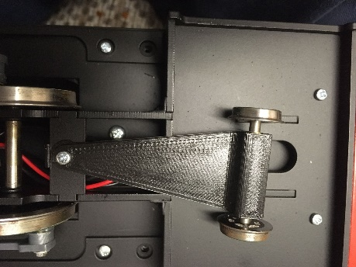

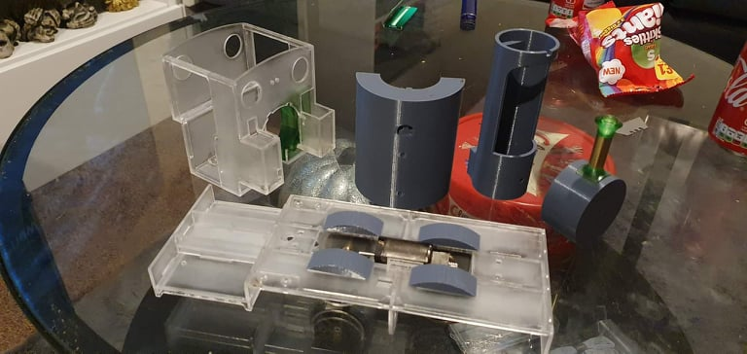
13. The 3D printed parts boiler first and the tank in cast resin on top.

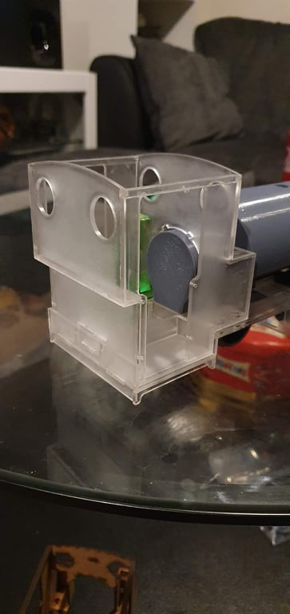
14.The fire box will fit through the laser cutting add detail later. All laser cutting will be for the cab be careful with two parts on top.

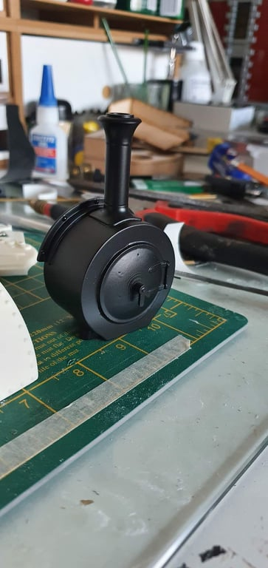
15. Next paint the smokebox in primer glue the chimney top and bottom to the tube. They are the green parts. Glue on the smokebox door black dart and leave to one side.

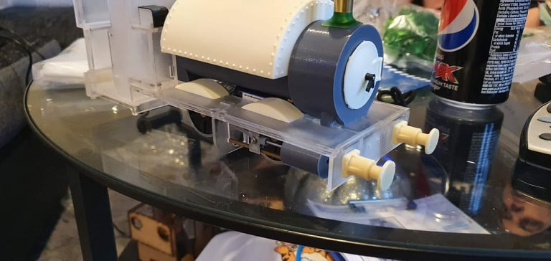
16. Resin cast parts front buffer with two squares and buffers inside glue together on the front of the loco.do the same for the back.

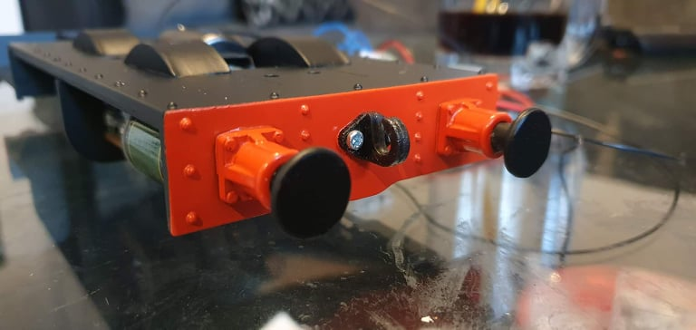
17. Two black hooks for the front and back in the middle of the loco
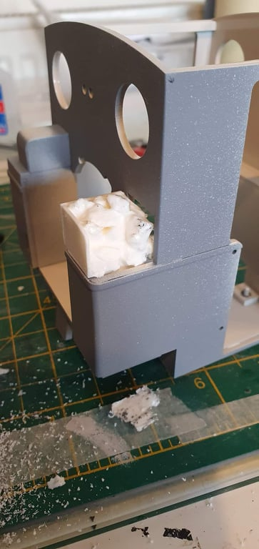
18.Resin cast part looks like coal glue to the side.

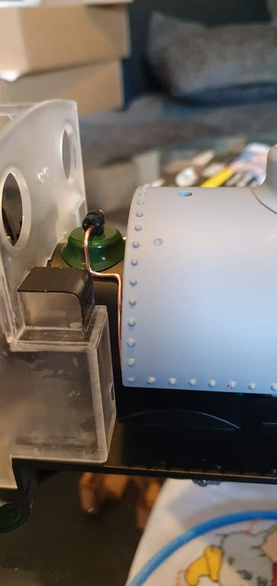
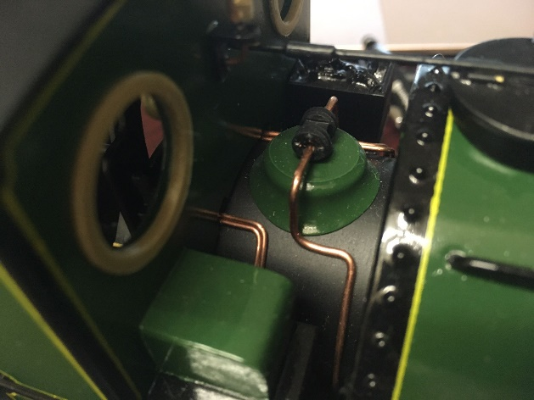
19. The small green dome shape and two small green parts to glue on top of the dome and add copper wire
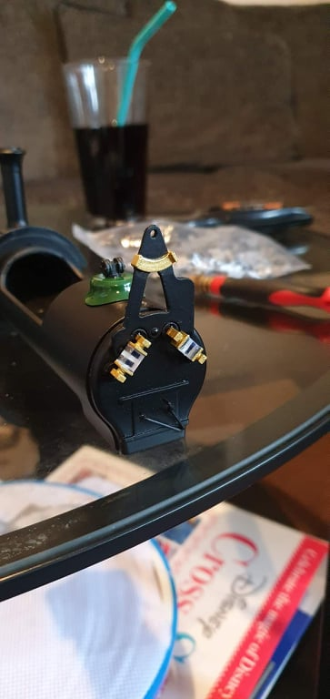
20. Resin cast shape V need to be glue on above two gauges glasses
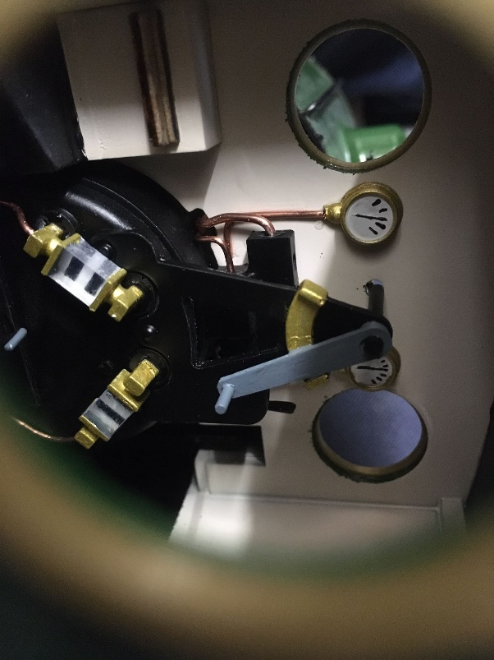
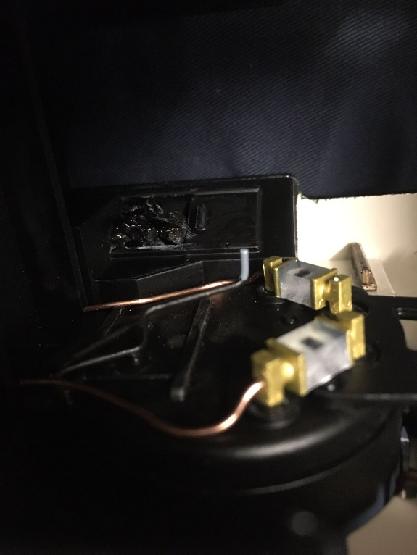

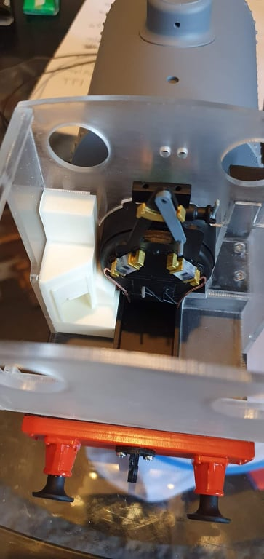
21. Resin cast coal bunker need to be glue next to the firebox detail on the left.

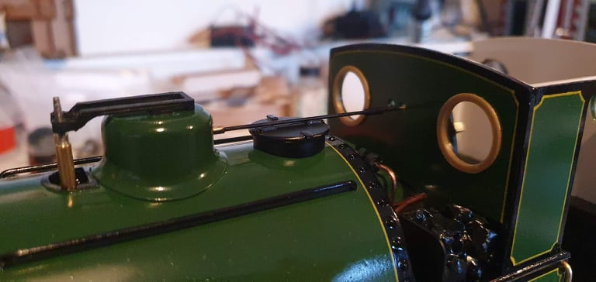
22. large green dome and next resin cast dome on tip of the boiler.

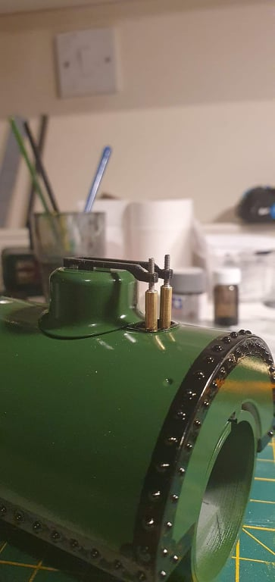
23.On the top off the large green dome need to glue on two handles cast in resin
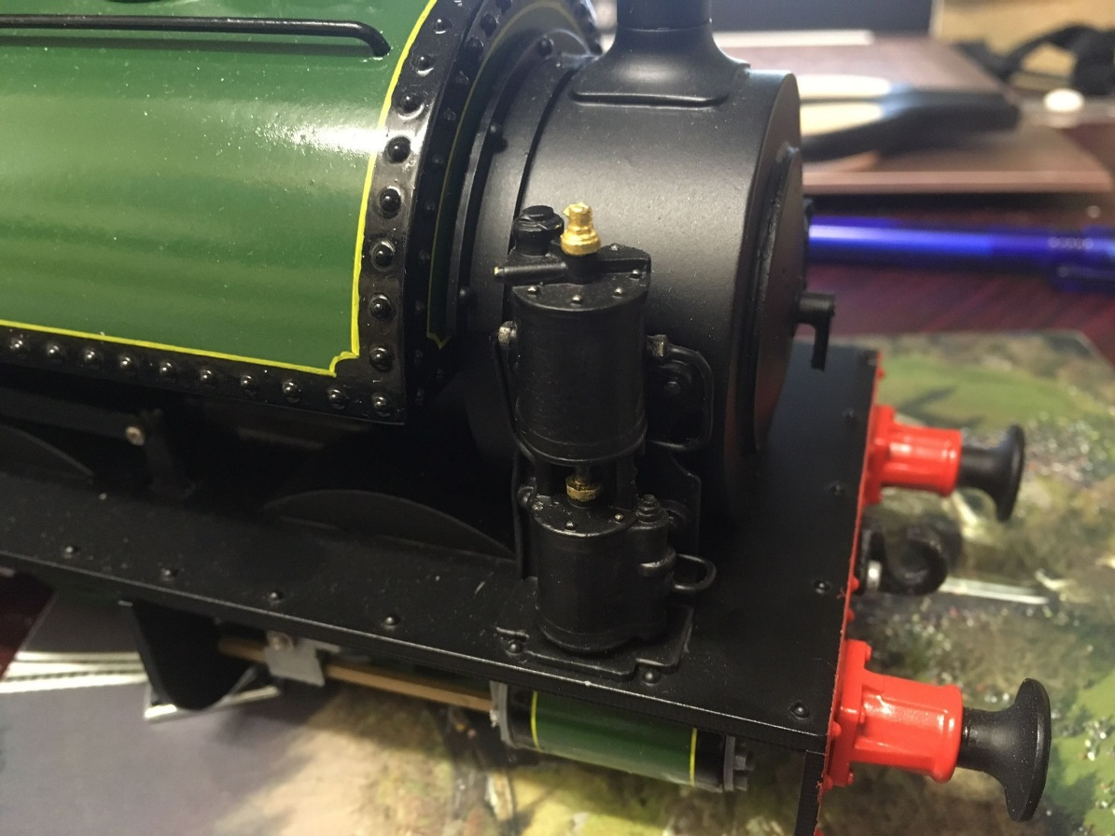

dose not come with Westinghouse Pump
https://www.swiftsixteen.co.uk/product-page/westinghouse-pump

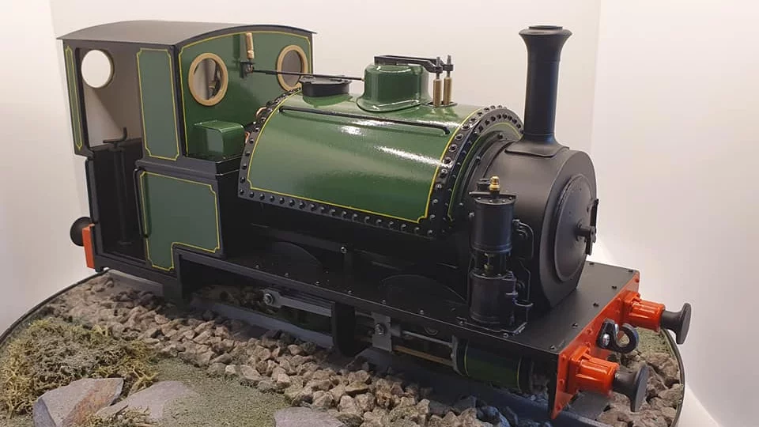
Thank you for buying this Loco kit. Please read all the instructions before assembly.
if your having any problems please get intouch
learobinsonpdf@gmail.com
07340 542782

