KERR STUART 4415

Familiarise yourself with all the components in the photographs

Clean up all parts with any burrs on the edges with a good quality file.

Open out holes with the correct size drill and a straight reamer of the correct size if necessary.

Adhesives are your choice but we recommend a good quality super glue, or Epoxy glue (Araldite).

Give all parts a light sanding first before priming, we recommend 500 or finer grade wet and dry.
Halfords primer is recommended.

TOOLS:

We recommend using good quality
Needle files or similar
Crosshead Screwdriver.(No1 Posidriver) NOT Phillips there is a difference
Craft knife or Scalpel
KEEP YOUR FINGERS WELL AWAY FROM SHARP BLADES

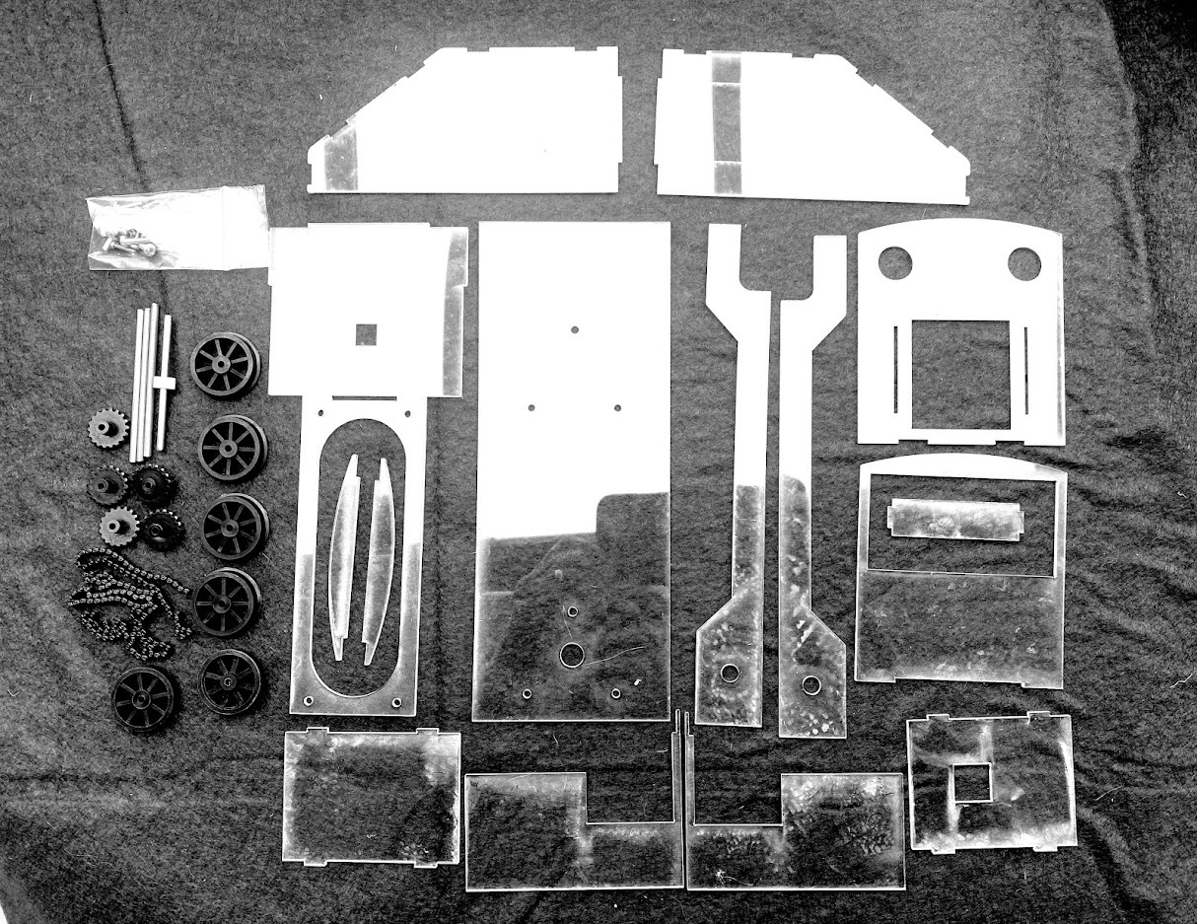
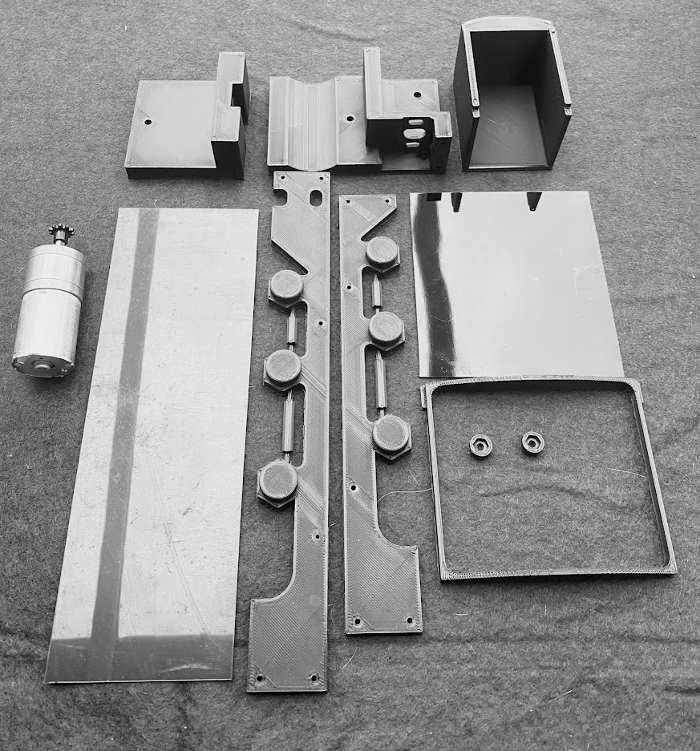

THE CHASSIS

1. Carefully drill out the axle boxes on the chassis with a 4mm dril to take the “tophat” bearings press them home (with a touch of superglue if required).

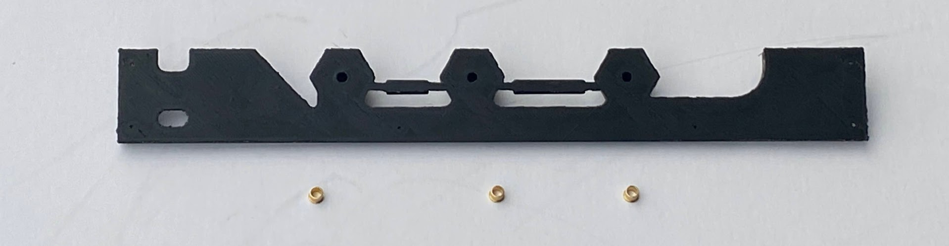

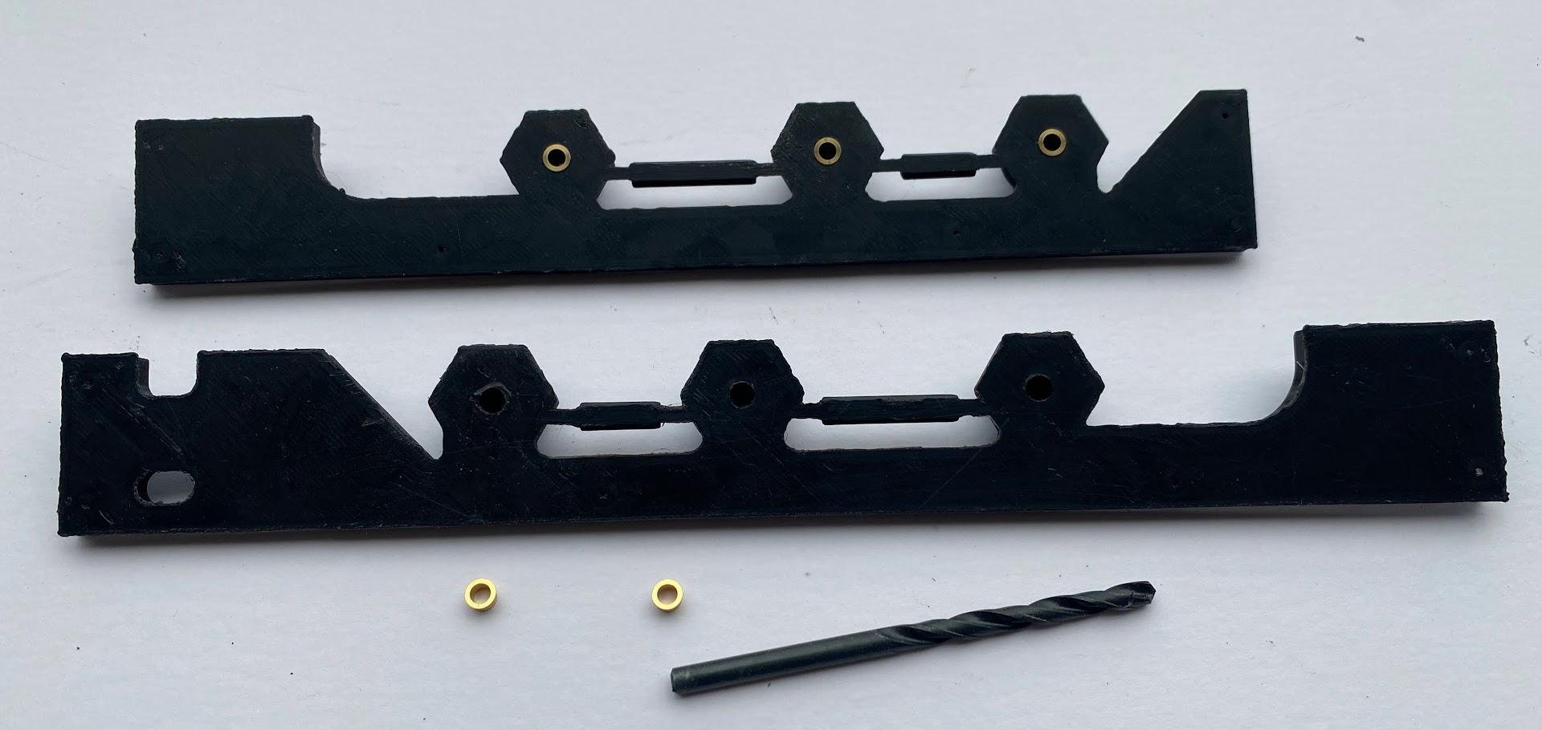

2. Take the motor housing and motor/gearbox, 2x 3mm x 6mm long bolts, 1 x 3mm x16mm long bolt and nut and the small Delrin sprocket (10 teeth), fit 16mm bolt and nut; next fit motor/gearbox unit using 3mm x 6mm bolts, do not over tighten them, fit the 10 teeth Delrin sprocket so that its short boss is flush with the motor shaft end.

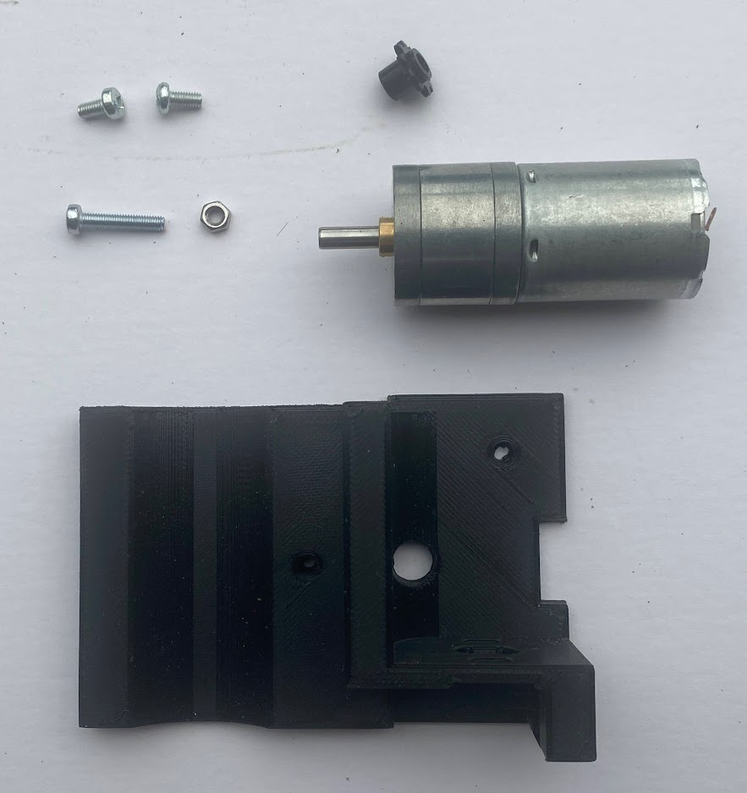

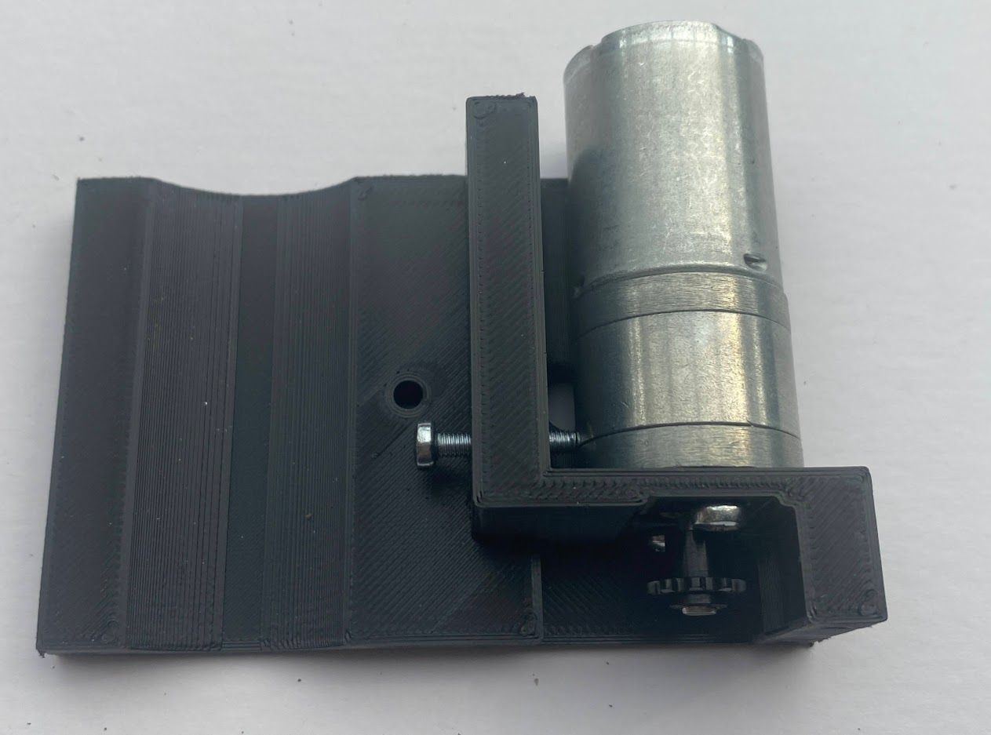
NOTE: THE SMALL DELRIN SPROCKETS ORIENTATION.

3. Push the wheels onto their axles being careful to have equal projections on each end. Very carefully push the larger sprockets onto these axles one axle only has only one sprocket and the axle nearest nearest the motor has its boss reversed to the rest.

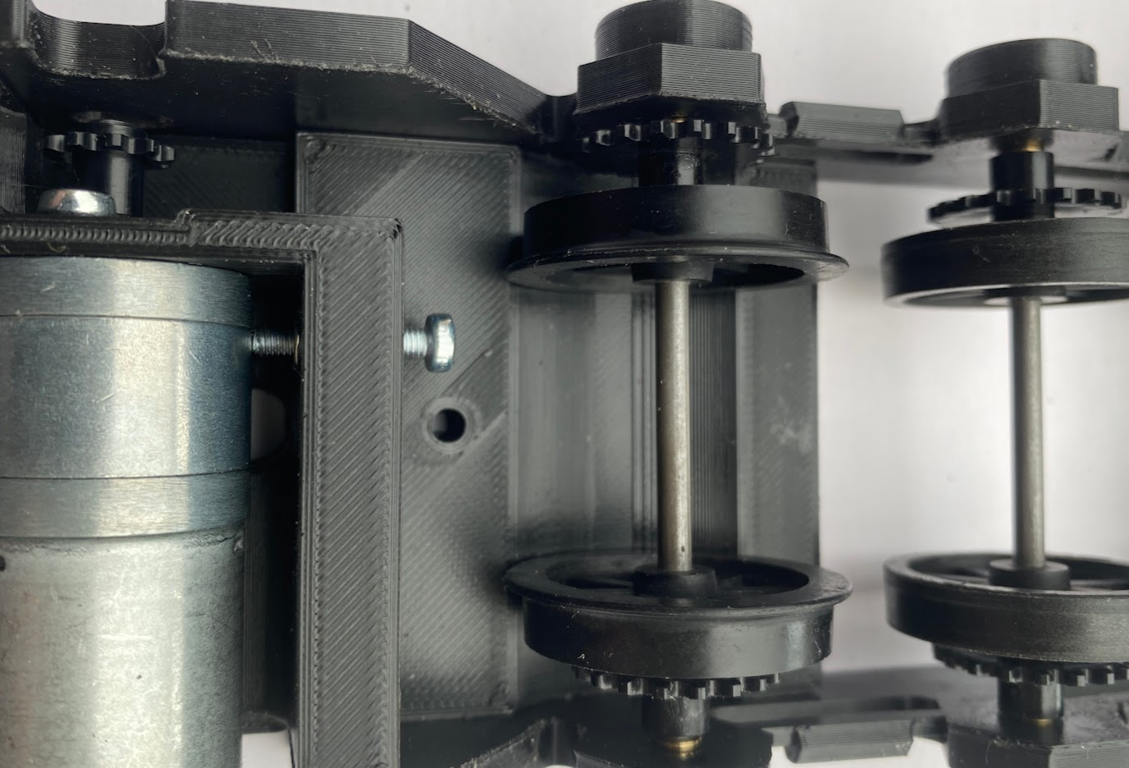

4. Add a small drop of clock oil (or similar fine grade oil) to each bearing. Test fit the sideframes to the motor housing and to the rear stretcher plate.
Taking 12 x 2mm x 10mm bolts and screw the frame/chassis together, check for free running of the wheels. Loosen off the screws and the screws holding the motor including the tensioning bolt.
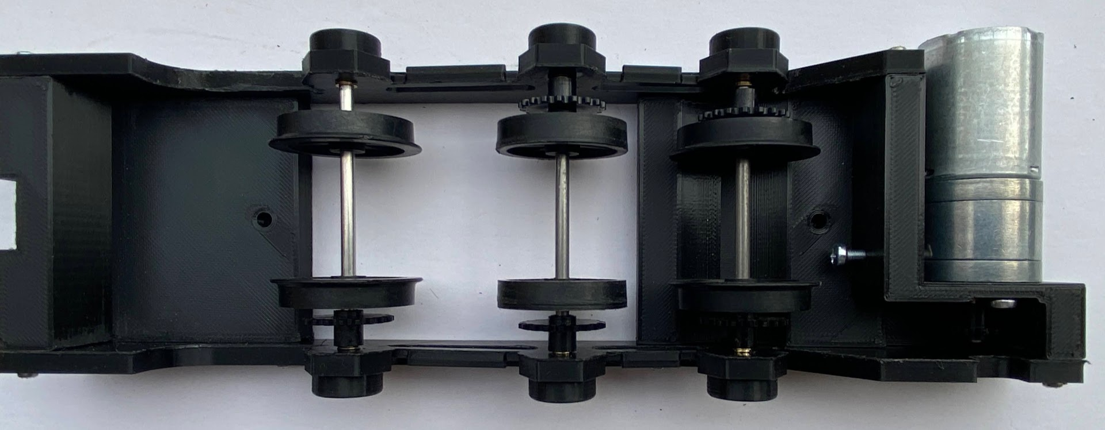

5. Make up the three Delrin chains into loops, release the axles from their bearings one side at a time. Slip the chain over small sprocket (MOTOR GEARBOX)and the first axle.
Tighten the bolts up but not too tightly for now.
Proceed to do this same process to the other axles. Once your happy with the fit tighten everything up fully. The motor tension bolt can be screwed up to the motor casing therefore tightening the drive chain you may then tighten the motor mount screws.
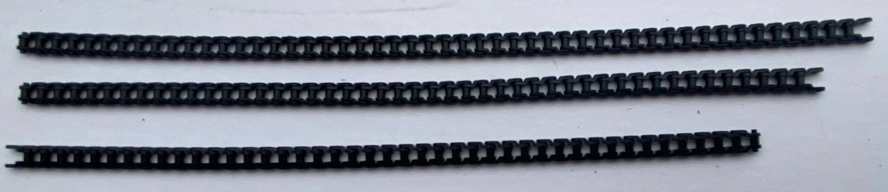

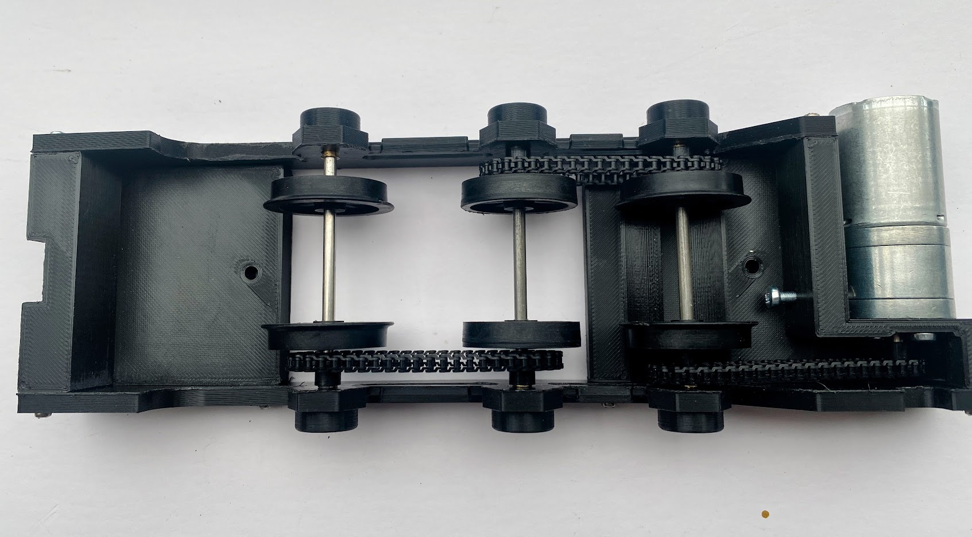

6 Test run the chassis slowly at first to bed everything in.

