THE DAWN LOCOMOTIVE
Thank you for buying this Loco kit. Please read all the instructions before assembly.
All 3D printed parts will need either filling with paints and rubbing down with “wet & dry”, or by
covering with a specialist resin coat. One of our customers covers the printed parts with paper with
very good results!
Certain tools will be necessary, screw drivers, pliers, tweezers, Allen keys, etc.
Another very useful tool is a tapered reamer!
TAKE CARE WITH THE REAMER - MAKE A SMALL CUT, TRY, AND CUT AGAIN.
Good results can be obtained from good rattle spray paints, Halfords is a very good source.
Many thanks
Leanne, Peter and Dave Farley
PDF MODELS
Learobinsonpdf@gmail.com

BASE OF LOCO
Glue side skirts to base and glue ends on with hexagon holes for 2mm nuts. ( 1. 2. 3)
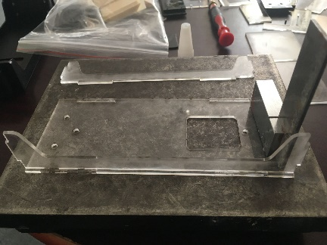
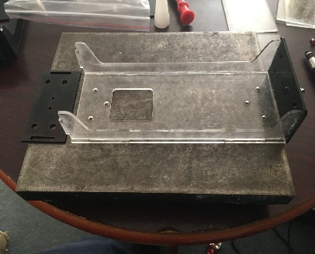
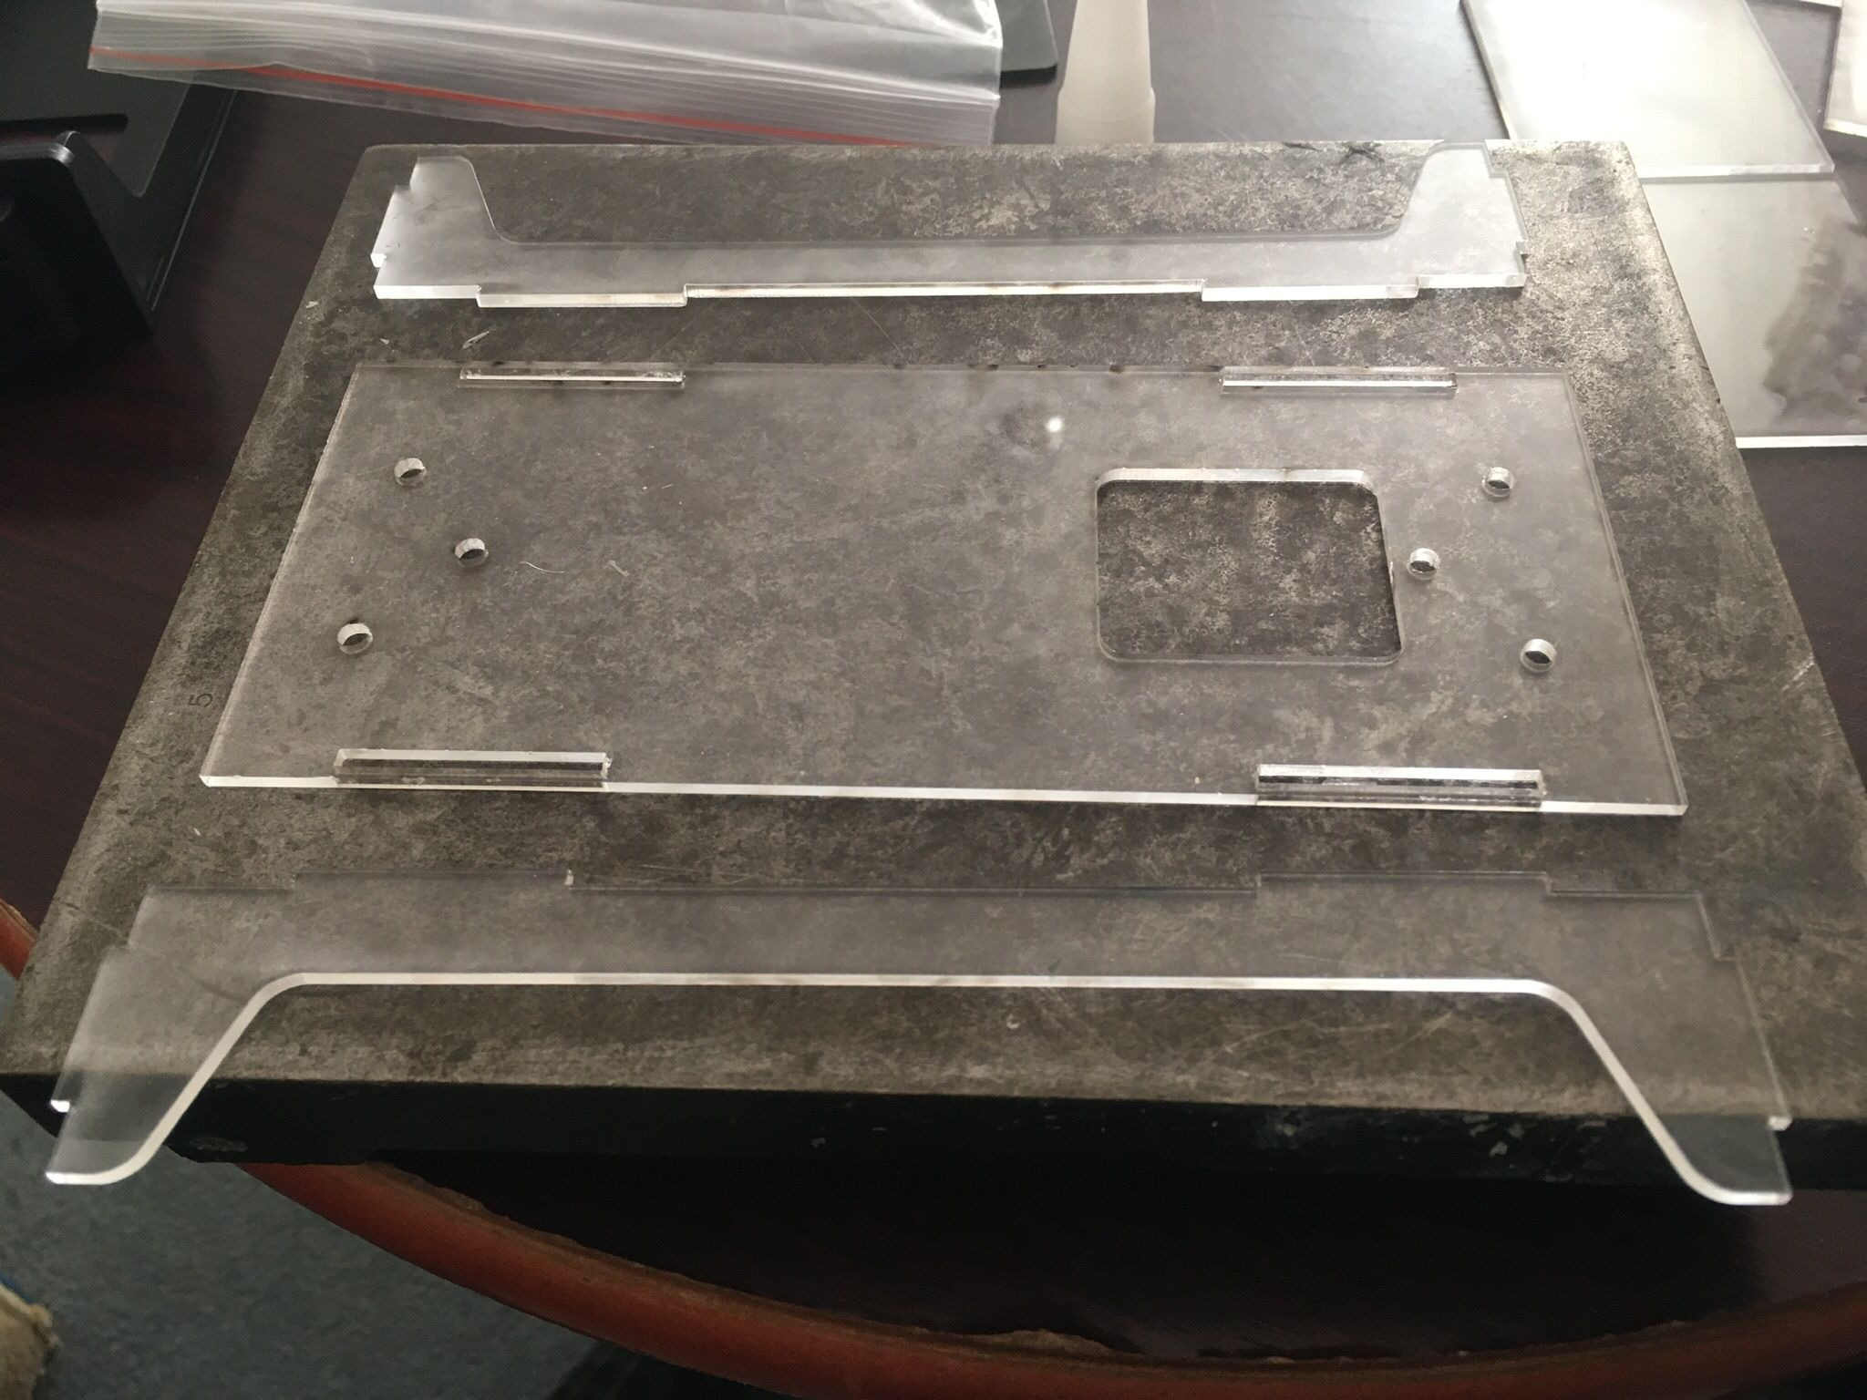

Glue buffer plate on to ends. ( 4 )
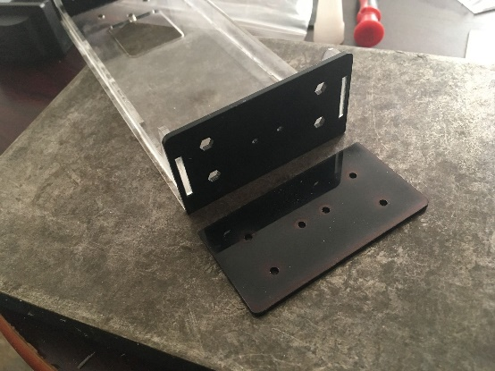

Glue 2mm nuts inside into the 4 hexagon holes.
Clean up buffers and bolt on to ends with 8x2mm bolts

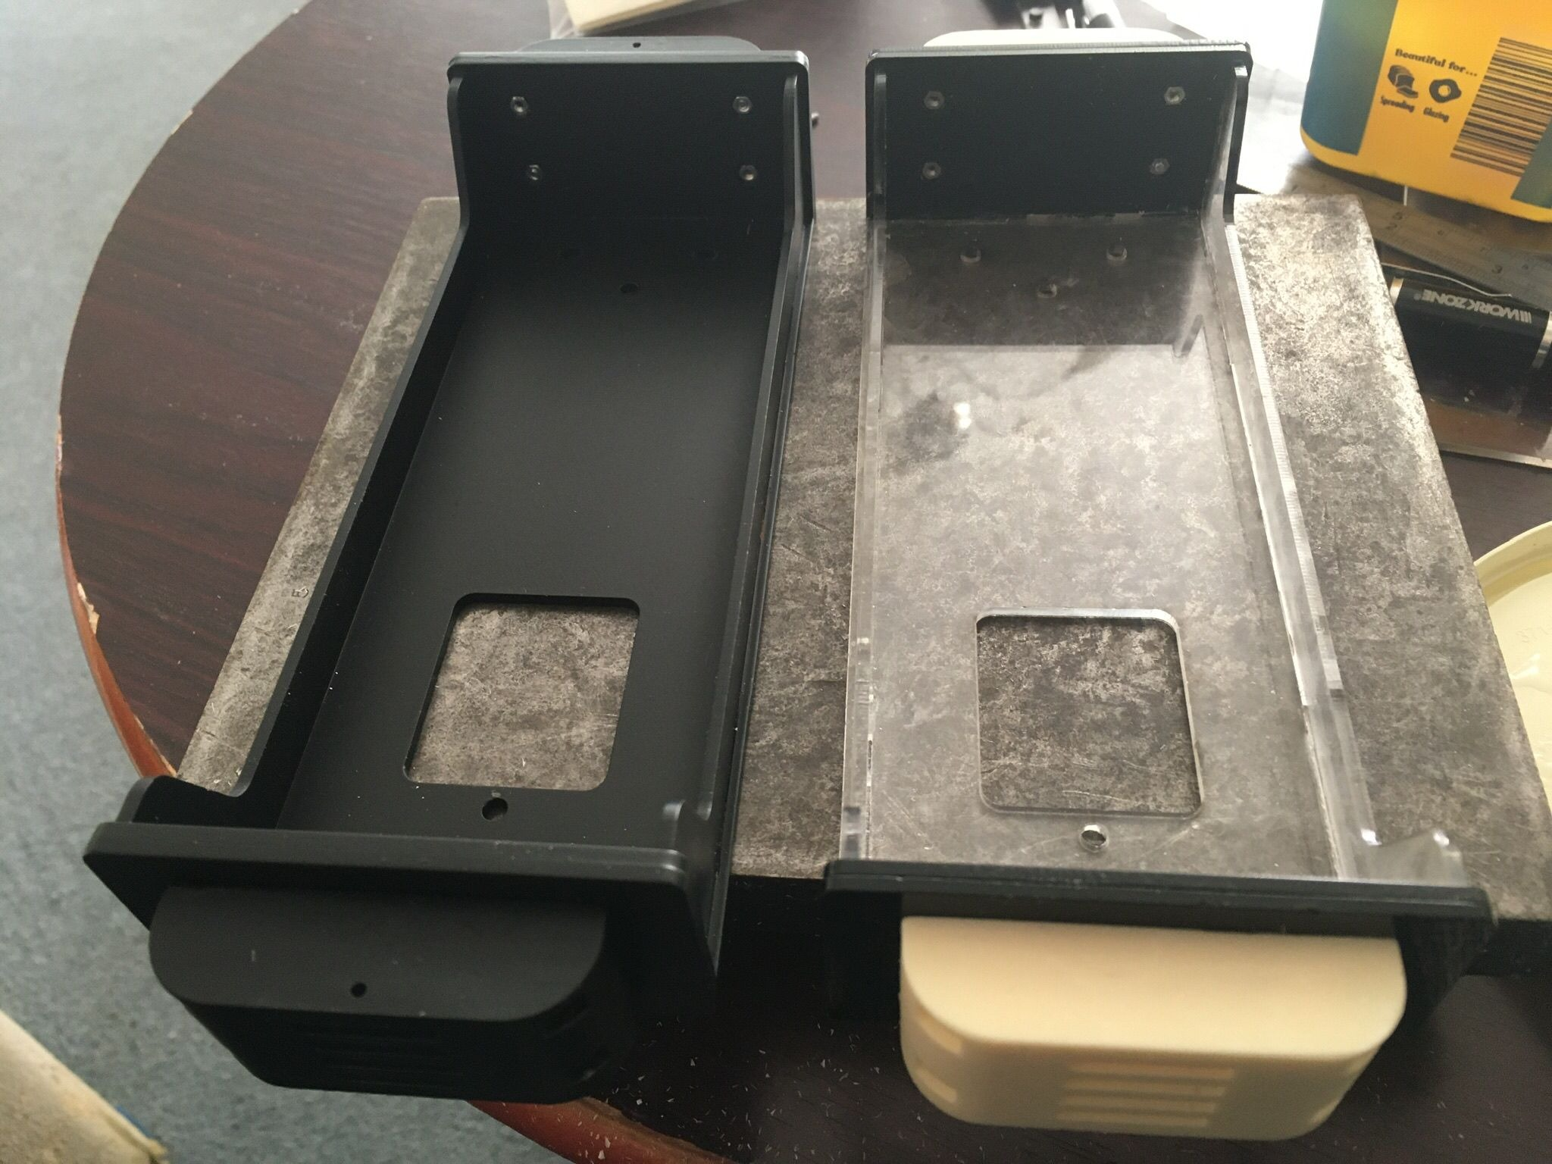
Rub down and paint black or colour of your choice.

BODY.

Glue cab footplate to base.
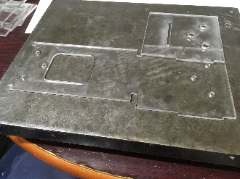

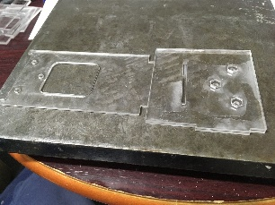

Glue bulkhead as shown in pictures.
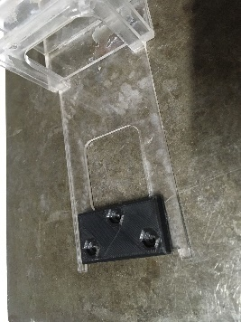
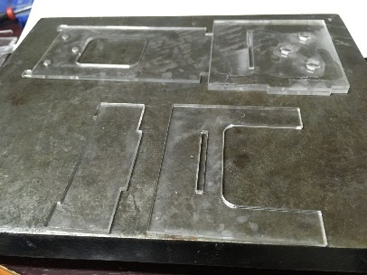
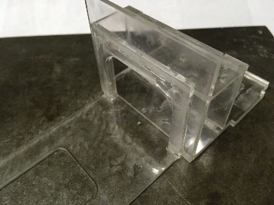
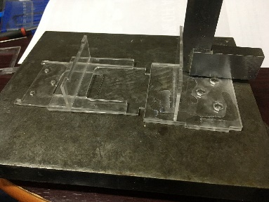
Glue 3d printed plate to base at front aligning holes.
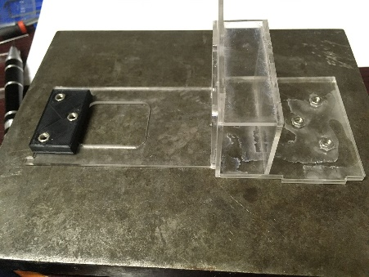

Glue 3mm nuts into hexagon holes front and back.

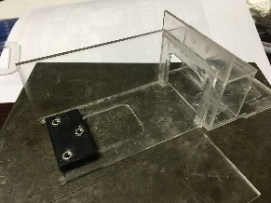

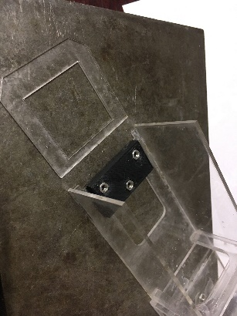
Glue loco sides and front.

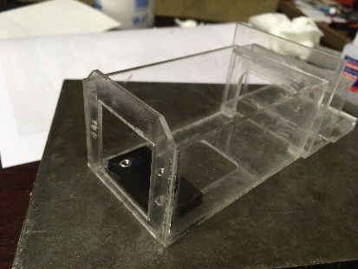
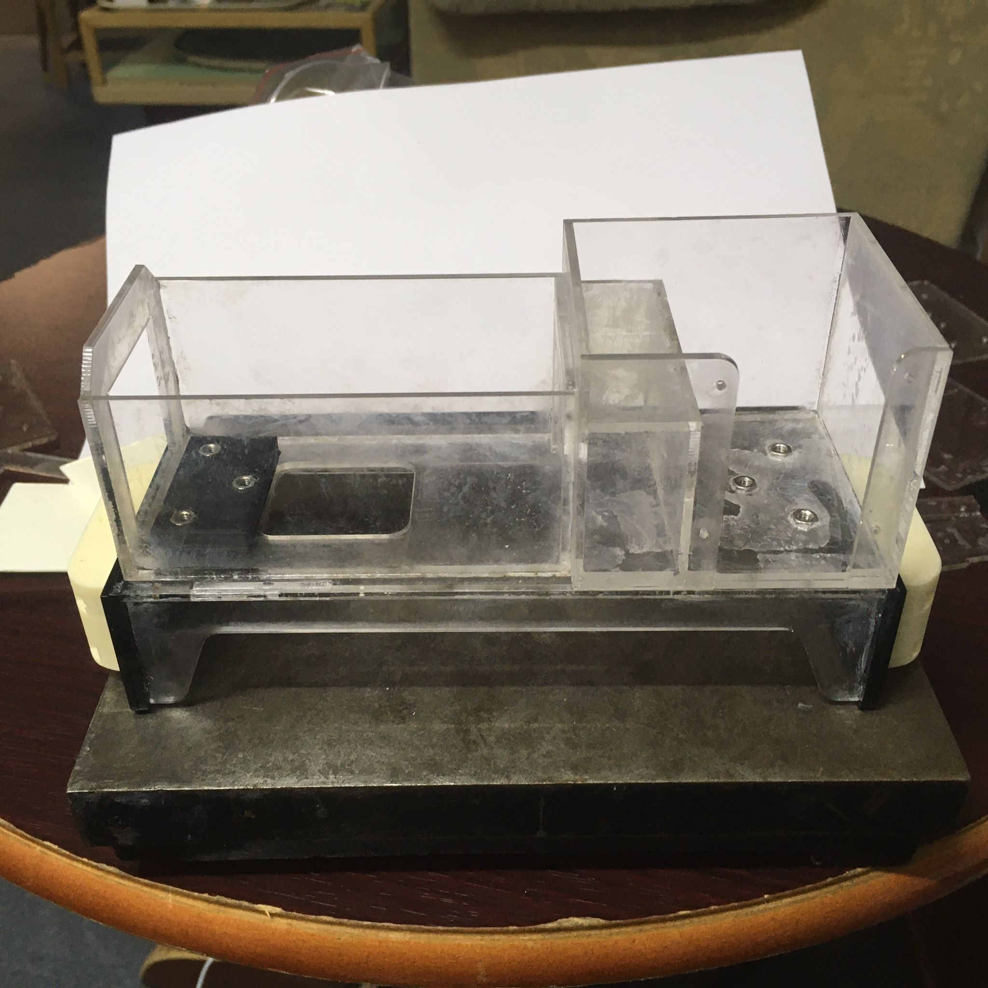

Glue cab sides and cab rear.
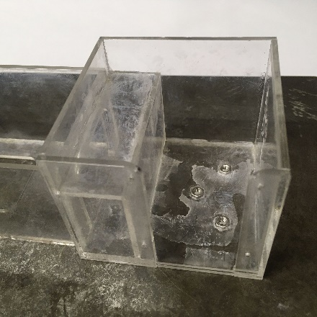

Rub down and fit bonnet glue brass chimney and paint with Loco.
Rub down grills and glue to Loco sides ( I used araldite gives you time to move into place )
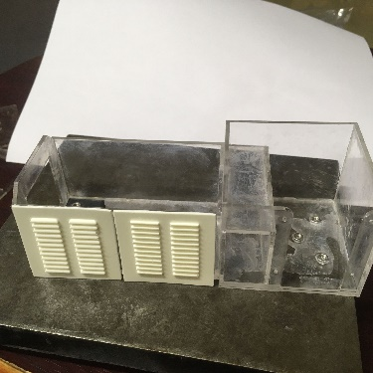
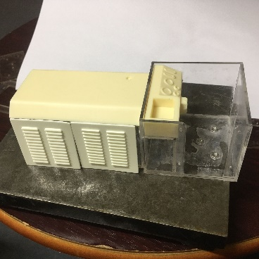

Rub down loco and paint whatever colour you require.
When dry glue black grill to front and controls in cab ( stick 3 pins in for levers and paint )

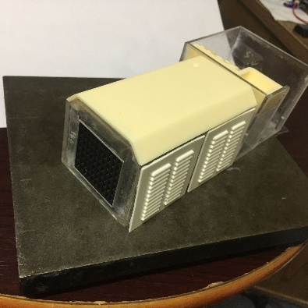

Bend 1.5 wire to make handrails and hooks for rope on rear if required.
Glue and fix in place.
When finished screw base to Loco with 3mm bolts front 10mm rear 6mm as in picture.
Painted Loco Body

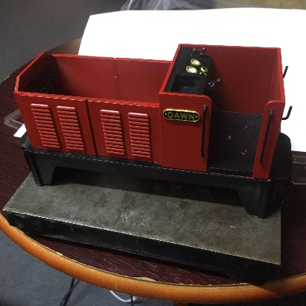
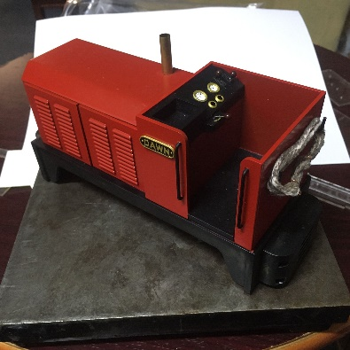
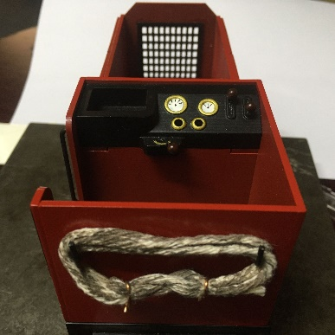
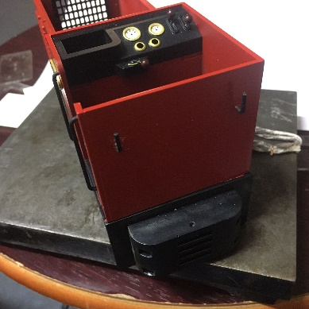

CHASSIS

The Chassis instructions is the same as the Baguley Drewry Chassis with a few Modifications.
It is a larger gear and axle boxes with springs on side of chassis
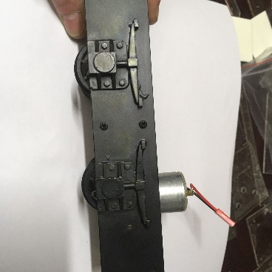
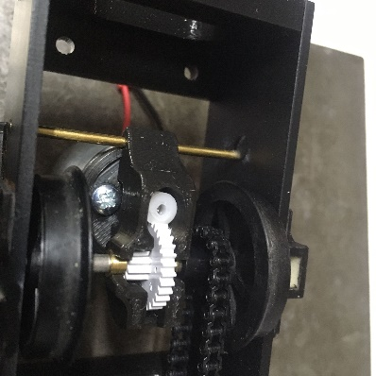

It bolts to underside of the loco with 2off 16x3mm bolts at the front and 2off 12x3mm bolts at rear.
